HANDOUT 1.2A: Zola
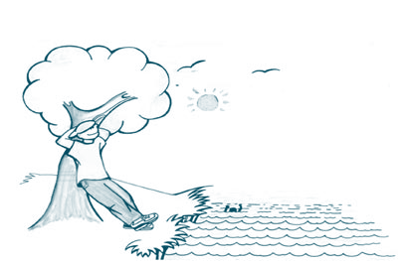
Slide 1

There was once a man standing by a riverbank and happily watching the world go by.

To his horror, he
suddenly saw a person ﬂoating downstream and in distress.
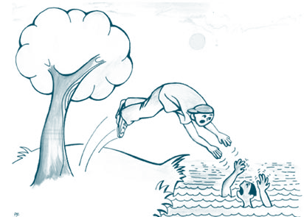
Slide 2
Without hesitating, he ﬂung off his jacket and jumped in the water. He pulled the drowning person to safety on the bank and got them
breathing again.
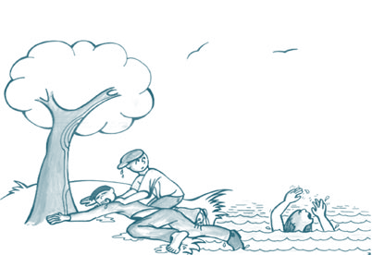
Slide 3

He was just about to go and get help, when he saw another person, also struggling in the water and obviously drowning.
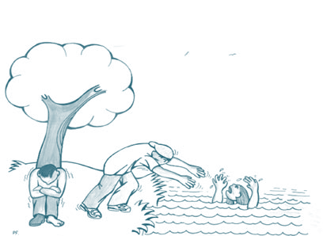
Slide 4
Again he plunged in and dragged them to the bank and revived them.
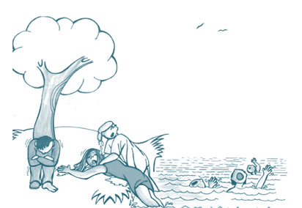
Slide 5

But no sooner had he done this when another and another person came ﬂoating downstream. More and more people came ﬂoating downstream and he had to work extremely hard to look after them.
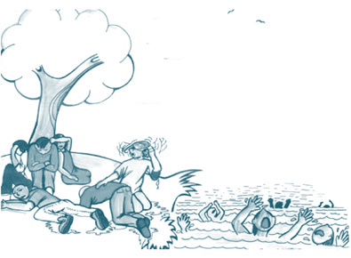
Slide 6
On his own he couldn’t save all of them
and many drowned.
Zola suggested that this is what the medical system does. Doctors pull people out of the water constantly and do their best to save lives, but they don’t look upstream to see who or what
is pushing them in.
Slide 7
Unless someone takes a look upstream, and begins to work on what is causing all these people to drown, more and more people will get into difficulties or die.
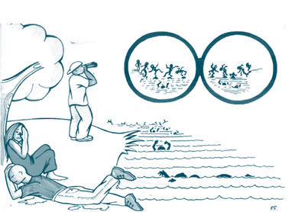

A collective, community development approach means you have to try to do both things at the same time and that in fact both things are linked. Together, you can support and help people individually, but you can also work together to try to prevent some of the problems

Slide 8
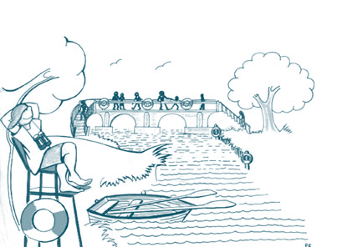

HANDOUT 1.2B: WHAT IS EXPECTED OF YOU THIS TERM
You should modify the following 5 paragraphs if participants are not going to go through the credit rating requirements.

1. Attendance
Try to attend each session, unless you have a good reason. Do let the tutor or someone in the group know if you are not coming. Your contribution is important to the whole group because we are learning and thinking together. Your ideas and experience are part of this course. This is important for all course members. In order to get your credit rating for Part 1 an attendance at least 6 of the units is required as part of your assessment.

2. Learning logs
On this course you will be asked to keep a few notes each week. Often, these will go in your learning log. Sometimes you might be asked to do other things. The learning logs are to help you to remember and to think a little more about what has happened each week. They will not be shared in the group, but your tutor will look at them from time to time. The learning logs are a part of the course assessment system for credit rating and you will be asked to submit them as part of your assessment. There are no right or wrong answers. Your tutor will be on hand to help you with them. If you like you may keep your own notes in addition to the learning logs.

3. Your contribution to the course
This course has been developed with the help of many groups in the community who have put in their ideas and comments about each session. Although the tutors will be presenting some information and organising the sessions around each week's topics, it is the course members' experiences and opinions which form the main part of this course. Health affects us all. We all have bodies and minds and we know what makes us feel well. When it comes to health, we are all experts.

4. Speaking up
The more you put into this course, the more you will get out of it. We are all different in the way we learn - some of us learn by listening, others by talking it out or writing.
Even if we don't feel confident in groups, it is important to speak up if there is something we don't understand, or we disagree with what is being said. If this feels too hard, you can use your learning log or take it up with your tutor. However, the groups who have tried this course found that if there is something you don't understand, you can bet that you are not the only one!

5. Credit Rating: If you are doing a credit rated course make the following points very clear.
This course offers a credit rating at SCQF Level 6. Requirements for the credit rating submission are:
Attend at least 6 of the 8 units
Take part in the group project
Complete your learning logs for each unit you attended
Complete the written assignment.

HANDOUT 1.6A: TRYING TO GET BACK
How are we supposed to make ends meet
The bairns continually under our feet
Work long hours to pay for this and for that
When Dad comes home they ask, “Who’s that?”
Families are cracking under the stresses
While politicians wives buy fancy dresses
So the New Parliament with your MSP’s
Please take note we’re down on our knees
We want to see our girls and our boys
Play with their friends and their fancy toys
We want to see them at University
We want to see them with a “job in the city”
We don’t want for our children the life that we’ve got
We want them to have work and achieve a lot
So when you’re making up your Constitution
Don’t sentence us to a life of destitution
The bairns are crying, they’re wantin’ their dinner
I can’t feed them cos’ I’m not a winner
I’m so worn down with the bills and such-like Christmas is on us, the bairns want a bike
How am I meant to find the will to survive
When the whole world is happy and I live in a dive
The wallpaper’s hanging not on the wall but down the back of the sofa - dampness made it fall
The carpet is tatty, it’s worn and it’s thin
The whole place is not fit for a tramp to live in
But this is the place me and the bairns call home
Let’s hope in the next century we can get in the phone
So First Minister with your policies and hype
Let me make a living so ma bairns get a bike!
Source: Writing about Health Issues: Volume 2

LEARNING LOG UNIT 1
What health means to me
- What I got out of today’s session. (Interesting information, anything new learned, enjoyed the session etc.)

- Things I would like to know more about. (Questions I have in my mind. Things I don’t quite understand.)

- What I put in to today’s session. (How I feel I contributed - listening well, supporting, offering my views etc. Note any difficulties, and how these felt.)

- Effects on individual health. List at least 5 things that affect your health as an individual.

- Effects on community health. List at least 5 things that have an impact on the health of your community.

- Connections and links. Can you give 1 example of how a community health issue affects your health as an individual?

